http://www.straightshooterschat.com/showthread.php/1911-To-all-out-there-that-have-rebuilt-an-RX2!
So I took the leap and broke my rifle down tonight. Easy as pie! Everything is pretty straight forward using the break down instructions I have. My only concern now is getting the trigger guard back on. But according to the instructions, that doesn't look like too much of a problem as long as I'm careful. Now since I didn't get the answers to many of my questions I originally posted above, I thought I would answer them myself. Now that I have the gun apart and have done more research, I know something!
1. How many "O" rings will I need. I know I will need a new piston seal?
2. What kind of grease do I use in the ram? How much should I grease it?
3. Any hard parts to consider buying before I start?
4. What bolts/screws should I use Loc-tite on?
5. What bolts/screws should I NOT use Loc-tite on?
6. Should I plan on replacing the Shrader air valve on the ram?
Answers:
1. In my gun there are four 'O' rings. Two at the back of the piston cylinder and two on the inertia plug inside the piston. I found out from Paul at Air Venturi that the older RX2s have the inertia plug with two extra 'O' rings on it, and the newer guns don't. I'm not sure what is considered newer. I bought this gun in 1995. Anyway, I'm only going to replace the two O rings in the back of the piston tube since the ones on the inertia plug do not effect the sealing of the ram. -TIP- Removing the inertia plug was a bit tricky since it is way down tight inside the piston tube. You've got to use compressed air to get it to come up the tube. I had to use a long nose air nozzle to apply compressed air through the small hole in the center of the plug which forced the plug up to the top so I could pull it out and inspect the 'O' rings on it. The rings were fine.
2. Still not sure what kind of grease goes inside the piston itself but it apears to be moly cause it's black. It could just be dirty tho. NOTE: —IMPORTANT TIP—Found out on the WOG forum that there should be NO GREASE OR OIL IN FRONT of the piston seal. Only behind the piston seal. The seal runs dry. If oil or grease gets in front of the seal the gun will diesel and the seal will get melted. Again DON'T GREASE OR OIL THE PISTON SEAL!
3. It's best to buy the parts after the guns apart, that way you only buy what's needed.
4. Not sure on this one but it appears none. When I took the gun apart no bolts had lock-tight residue on them.
5. Already answered above.
6. The shrader valve is behind a sealed bolt that has an 'O' ring on it. If the shrader valve leaks and the bolt is kept tight, the air has nowhere to go. Therefore if the valve leaks it doesn't matter. Answer is -NO.
I'll post some pics when I get a chance.
T-bone out.

So here are some pictures to start.
Broken Down:
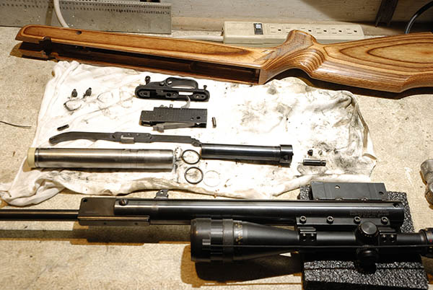
Now I want to show and explain something that I haven't seen posted anywhere on the web.
It's an explanation of how to get the floating inertia plug out of the piston tube to replace it's 'O' rings.
Floating Inertia:
The photo below shows the floating inertia plug that's down inside the piston tube. It must be removed to replace the two 'O' rings on it. Since the plug is tightly held by it's 'O' rings, there's no way to pull it out, and nothing on the plug to grab on to.
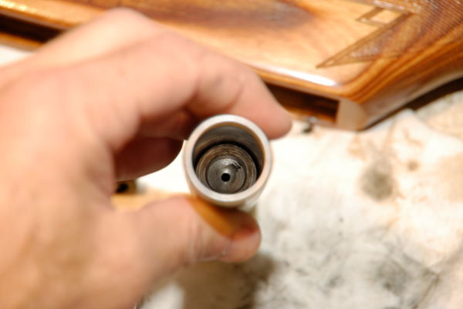
Note the small hole in the center of the plug. I used compressed air and a long nose rubber tipped blow gun to apply air pressure into the small hole in the center of the Plug. I slowly started applying the air pressure from the blow gun until the plug began to travel up the tube. Once it got to the top I simply pulled it out easily with my fingers. This is why they designed it with a hole in the center. Otherwise there would be no way to easily remove it to replace the 'O'rings! Pretty clever of them eh?
Inertia Removed
Here's a picture below of the floating inertia with it's 'O' rings. after removal.
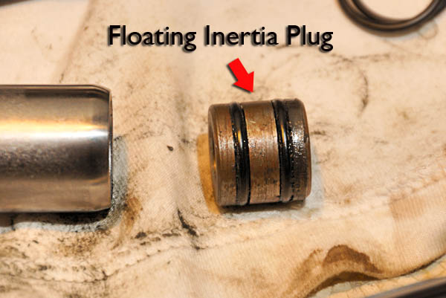
The 'O' rings on the inertia don't contribute to any sealing of air inside the piston strut. The 'O' rings only function, is to provide some resistance as the inertia block slides back and forth inside the strut tube during the firing cycle. It's nothing more than counterweight that moves back and forth. Therefore, in my opinion, there really is no point in replacing the 'O' rings on it unless they are really worn out to the point that they don't provide any resistance.
The 'O' rings on mine are fine so I won't be replacing them. Just wanted to show a close up picture here, so I removed it for the photo.

The Piston Seal:
I was surprised. The way the gun was shooting weak, I suspected the piston seal to look horrible. However, as you can see here, it's discolored on the face but the sides where it seals don't look bad at all. It's possible that the face has a hairline fracture that I cannot see and air is escaping through the crack and out under the seal during the firing cycle.
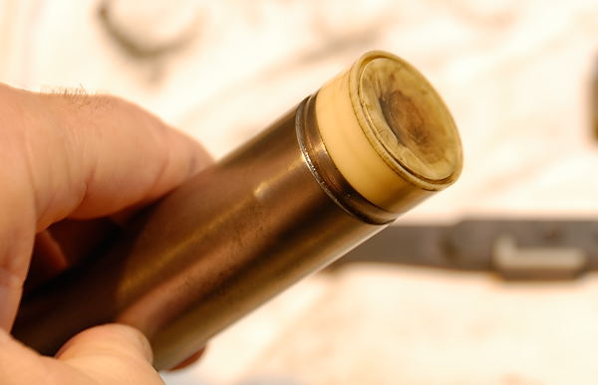

The New parts arrived from Pyramid Air!
1 Piston Seal BNP-9069
2 'O' rings for the inside of the piston tube BNP-2030
1 Back-up seal for the inside of the piston tube BNP-2031
Some Observations:
Other than the obvious color difference, I noticed that the new piston seal has some physical differences/improvements from the old one. As noted in the picture below, a grease retaining ring lip has been added to the bottom of the new seal. This helps keep the grease in back of the compression tube where it belongs…"Behind" the piston seal away from the compression area.
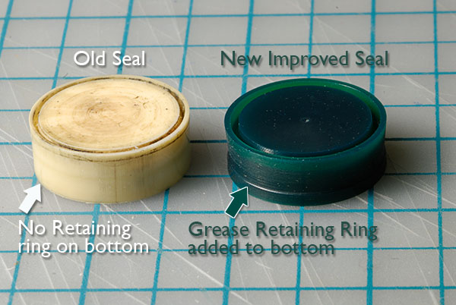
Note in the next photo, the difference in the face of the old and new seals; the front seal lip on the new seal is thicker, (see arrow) than the old design and the groove looks wider. This new seal also fits much tighter in the compression tube. The larger groove should allow more air to expand the lip more during the forward stroke, for a more efficient seal. Once I install this new beefier seal, there should be a big improvement in performance.
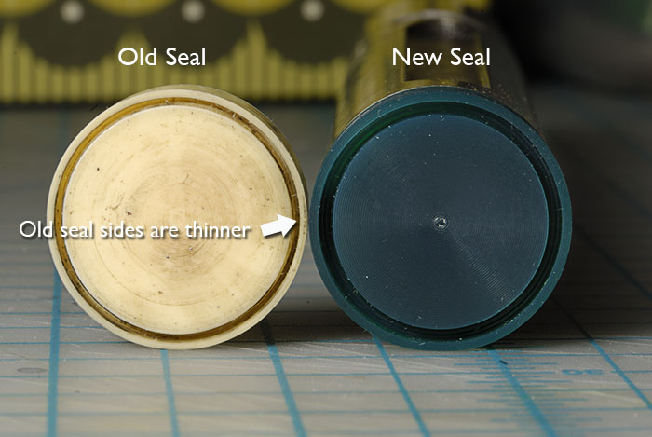
Tips On Removing The Old Piston Seal:
The piston seal is mounted quite snug to the top of the piston tube dovetail. It takes just the right thin but strong tool to get between the seal and the piston tube to pry without damage to the piston dovetail that's under the seal. I found a common dull table knife to work best. Don't use a screw driver! It's got sharp corners and isn't wide enough. I had read, that most people will gouge the metal dovetail under the seal, which creates a rough barb in the metal. Then, when the new seal is fit it hangs up on the barb. The seal should fit snug but turn freely when properly fit to the top of the piston tube. You should be able to spin the seal with your fingers. I used a common table knife that had NO serrated cutting edge. In fact, the cutting edge was not sharp but rounded slightly. Basically a dull table knife. The dull blade was just thin enough to get between the seal and the piston tube. Try not to go under the seal more than an 1/8 of an inch, then twist the knife to raise the edge of the lip of the seal off the dovetail. Once you get part of the lip raised, use your fingers to pry the seal the rest of the way off. You may have to try a couple times. Remember, your trying not to scratch the metal retaining lip under the seal. Patience is key.
The new piston seal should press on with your bare hands. Just start part of the seal on to the dovetail then work your way around the seal to finish snapping it on. Then turn the seal with your fingers to make sure it's seated properly. It should turn freely. That's it.

What some cocking lever rivet/pin wear looks like after over 17,000 rounds!
A closer inspection of the cocking lever, retaining rivet pivot pin and glider piece reveals some significant wear. I think this is normal for a gun with over 17,000 rounds on it and no rebuilds in it's past. My left arm is getting sore just thinking, it translates to 17,000 times cocked!
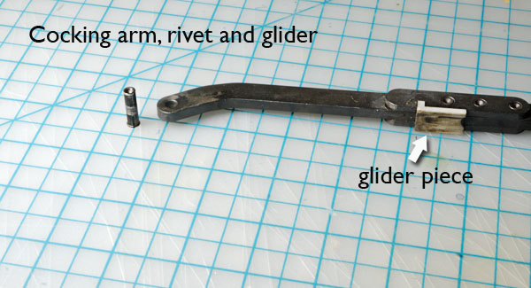
The Cocking Lever Rivet/Pivot Pin:
Check out the close up below of the cocking lever rivet pin. This pin takes the brunt of all the force of cocking. It's galled pretty good on one side where the cocking lever pivots. On the opposite side of the rivet where there is less pressure from the cocking lever, the pin is almost smooth. I plan on re-using the rivet pin but I will turn the smooth side toward the lever when I assemble the gun. Looking inside the cocking lever rivet hole, I didn't see much wear on the inside surfaces. Next rebuild I will replace the rivet pin though.
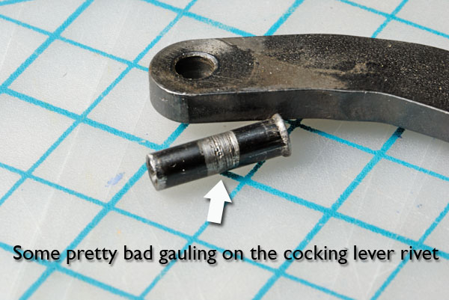
Plastic Glider Piece:
The plastic glider piece has some wear on it too but it's not worn out. It looks like some grit got underneath it by the looks of the long gouges in the plastic. I think a good cleaning and greasing on it will do just fine. For those that don't know, the glider piece slides along the outside of the compression tube as the gun is cocked and the cocking lever moves. All this goes on beneath the stock, so it's impossible to keep that clean without removing the stock from the action.
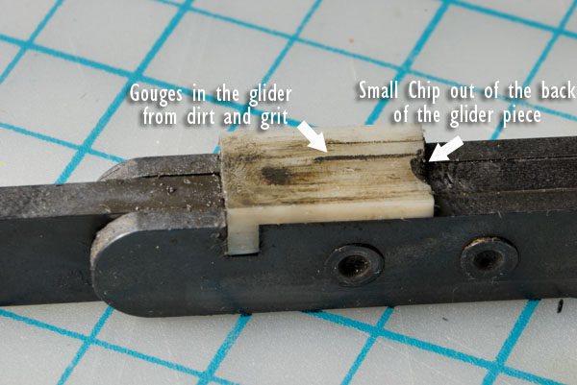
More on the cocking arm rivet pin:
The picture below shows the breech block of the RX2, (HW90). I wanted to note here that the cocking arm rivet pin that goes through breech block, only fits one way through it's hole from this side shown here. The hole for the pin is .003" smaller on the other side. So when you drive the pin out, it must be driven OUT from the other side, or (smaller hole side not shown). The pin is driven IN from the side shown.
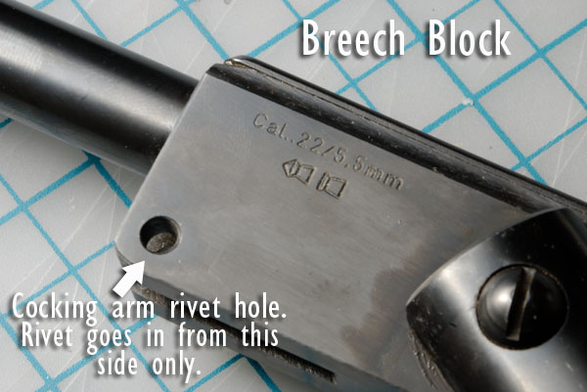

Understanding the Schrader Valve:
If you plan on replacing your Schrader valve, there are a few things you need to know first. After reading this you'll find, you probably DON'T need to.
I have heard from others and at one point believed myself, that if you remove the little screw from the air transfer port covering the schrader valve, and hear a tiny bit of air escape, the schrader valve is bad and needs to be replaced. I found that this assumption is USUALLY WRONG. Just because a little puff of air is released when you loosen the port screw, does NOT mean the valve is bad. Some air leakage from the Schrader over time is normal, so the little puff of air when you loosen the port screw is also NORMAL. Only if you remove the screw, and the escaping air sound is constant, you then have a problem with the valve and it should be replaced.
I discussed this with Beeman's repair guy, David Slade and he says, "That's why they designed transfer port screw with an 'O' ring." "If the screw is kept snug, the air is held in, and has nowhere to go".
In other words, Beeman knew that the Schrader valves leak. The screw and 'O'ring are a back-up safety to hold the air in. So don't be unscrewing the screw unless you are planning to put air in the ram. Because every time you loosen the screw, you let a small amount of pressure out. Make sense? Yep.
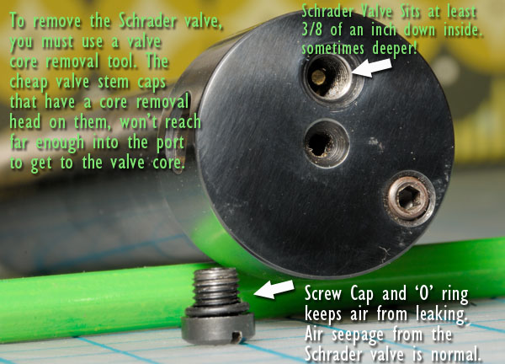
If you do find that the Schrader valve is bad, you will need the proper tool that's designed to remove it. That tool is a Valve Core Removal Tool. (See photo below). You can get one at HERE at Sears.
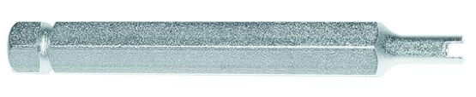
NOTE: The cheap valve stem caps, that double as a valve core removal tool, won't work, because they are too short to reach the valve core. Beeman places the core way down inside the port at least 3/8" and only an actual Valve Core Removal Tool is long enough to reach the valve.

Sharing some BooBoo's and lessons learned.
So I thought I would share some problems I have encountered with my rebuild of the RX2. I wanted to share this so others don't make any of the same mistake(s) I did.
Once I got the gun put back together, I couldn't wait to try out my newly adapted shock pump and get pressure back in the ram. I hooked up the pump and started the pumping process, but the air was escaping somewhere in the hose connections. At first, I could only get about 100 psi into the ram before I would see the gauge needle slowly creeping down. I re-snugged all the fittings and started over. It worked better, but now @ 200 psi I could see the needle start dropping faster than I could put air in.
I spent about 45 minutes trying to figure out where the air was escaping and gave up. I got frustrated messing with the shock pump and my arm was getting sore, so I switched to the old original Beeman pump with no pressure gauge. (Mistake)
I must say, the bike shock pump is a bastard to pump after 200 psi. It's because the pump has a short stroke and because of it's very short hose. It works, but you're forced to use both hands to support the pump and hose connections, otherwise you put too much pressure on the fitting that goes into the gun. You don't want to break the fitting off inside the transfer port of the ram! The Beeman pump is much easier to pump, since it compounds the leverage of your stroke. It's hose is also longer. However, mine did not come with a guage! The pellet velocity method must be used to determine, (or estimate) the correct pressure. This turns out to be an unreliable way to fill the ram from 0 pressure to full.
Using the Beeman pump without a gauge, I used the pellet velocity method of filling the ram and shooting over the chrony to check the velocity. But there is an inherent flaw with this method. Without a gauge, you never REALLY know HOW MUCH actual air pressure your putting in the ram to achieve a certain velocity. As I found out later, I ended up over-pressurizing the gun, even though the pellet velocity did not exceed the velocity specs. on the chart by more than 10 fps! I had shot quite a few rounds before I noticed some vapor coming from the muzzle and a weird smell of plastic. Oooops! I also should have backed off the pressure earlier, or checked the cocking pressure, because the gun seemed extra hard to cock. Later, when I tested the cocking effort on a bathroom scale, I found that indeed, the cocking effort was way high, at around 10 to 15 lbs over what it should be, (46lbs). (http://www.youtube.com/watch?v=mV1I-H_irF4)
I broke 'er down again to check the piston seal. All my anticipated fears were confirmed. when I found that I had melted the seal real good! I also hate to admit it, but when I first got the ram up to pressure, I had cocked the gun and forgot to put a pellet in it before I shot it over the chrony! I heard a the classic loud CRACK when it fired. That was my first clue that I'd be taking it apart again!
Here's a picture below of what the piston seal looks like after both screw-ups.
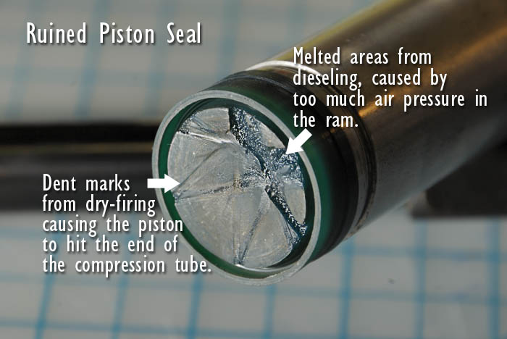
Here is a picture below of the inside of the RX2 Compression chamber. Note the air channeling grooves that direct the air to the exit port. When you look at the piston seal in the photo above, you can see a stamped imprint of the air channel grooves from the end of the compression chamber permanently stamped in the seal. This is why you shouldn't dry fire the gun! It compromises the seal, even if only done once. As was the case here.
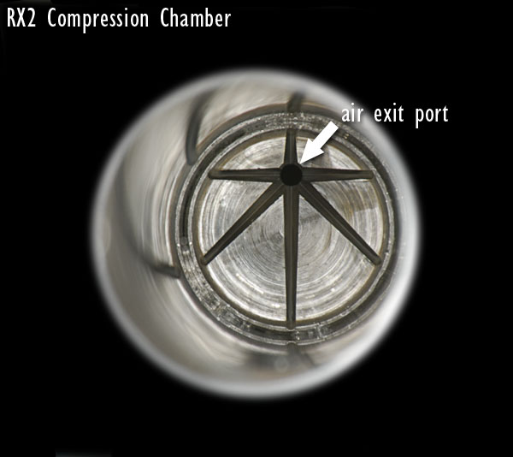
BTW, I figured out what was wrong with the bike shock pump. The problem was two-fold. First, the valve at the end of the hose had gotten some junk in it causing the air to bleed off at high pressure. I also found that the gun's Schrader valve was bad, cause when I disconnected the hose I could hear air leaking back out of the inlet port. Luckily I happened to have an extra Schrader valve.
The motto of this story is SLOW DOWN! and DON'T BE TOO ANXIOUS! If your NOT using a guage, check the cocking pressure on a bathroom scale when you think you have the gun pumped up to pressure, BEFORE shooting a bunch of rounds through it. If cocking pressure is over 46lbs, you'll likely be melting the piston seal, so let some air out first.
Here's the youtube video below, of how to use a bathroom scale to properly check the cocking effort of your gun.
http://youtu.be/mV1I-H_irF4
If I had waited and solved the problem with the bike shock pump first, I would have not overfilled the ram, cause I would have used the pressure gauge. Also, being too anxious caused the mistake of dry-firing the gun! I had clues that the pressure was too high but I ignored them.
Oh well, at least it's only $15 for another piston seal and some lessons learned. I'll report back on this when I get the new seal put in.

Got the new piston seal and put the gun back together:
Since I was taking the gun apart again, I ordered a new cocking lever rivet pin when I ordered the replacement seal. I'm glad I did. There's quite a dramatic difference when looking and the new one and old worn one. As I said before, the wear your seeing on the old pin in the photo = 17,000 cocking actuations. The gun should cock smoother and there should be less wear on the to the cocking lever now, after installing the new pin. Don't know if it's done in the factory, but I'll apply a small amount of moly to the new pin before I drive it in, to help prevent future wear. It should be able to take another 17,000 cycles again after that. The pin is slightly different than the original. If you look closely at the photo you'll notice it's a touch longer. It fit in just fine, but didn't wedge tight like the original. Kinda floats back and fourth and can be installed either side of the cocking lever arm. It stays put okay.
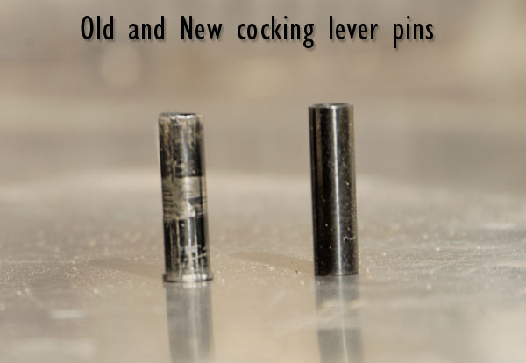

Cleaning the compression tube:
I wanted to cover cleaning the compression chamber tube. It's REALLY IMPORTANT that you clean all the old moly grease out of the compression tube BEFORE you re-install the piston and new seal back in the gun. Why? Because you DON'T want moly grease on the piston seal or in front of the seal where the compression happens. If you were to leave the old grease in the tube, the new piston seal would get covered in grease when you slid the piston back in the gun. I used degreaser on a shotgun patch with a soft head tip, to clean ALL the grease from the compression tube. When the patch comes out clean the the tube should be clean. I also used a small flashlight to inspect the tube after cleaning.
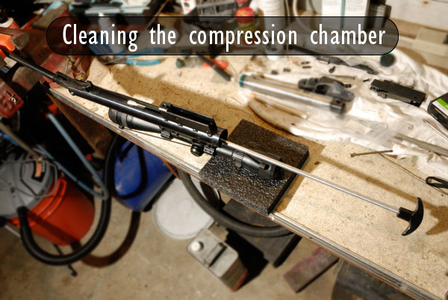
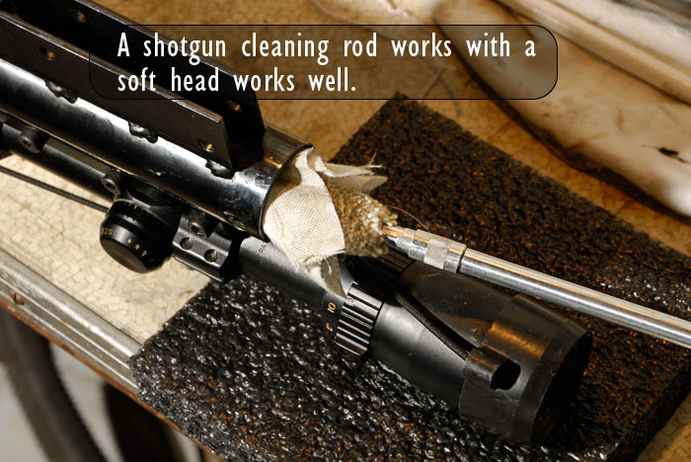
Applying moly to the piston:
Only put a VERY light amount of moly paste/grease on the metal part of piston. You do this right before sliding the piston back in the clean compression tube. DON'T put grease on the piston seal and make sure you DON'T push grease in front of the seal when you reinstall the piston. If you get grease in front of the seal, it may cause the gun to diesel, which will melt the seal. In addition the grease would be forced into the barrel when fired and make the gun a gummy mess. From what I have read, you don't want ANY grease to touch the piston seal at all. The piston seal should run dry against the dry greaseless part of the compression tube during the firing cycle.
When putting new moly paste on the metal piston pipe, be careful. I only applied a thin coat to the metal edge just behind the seal, and then to the rear of the pipe where it rubs the compression tube. The first time I put the gun back together, I think I used too much moly paste/grease. The photo below shows how I now applied the moly sparingly to only the metal part of the piston.
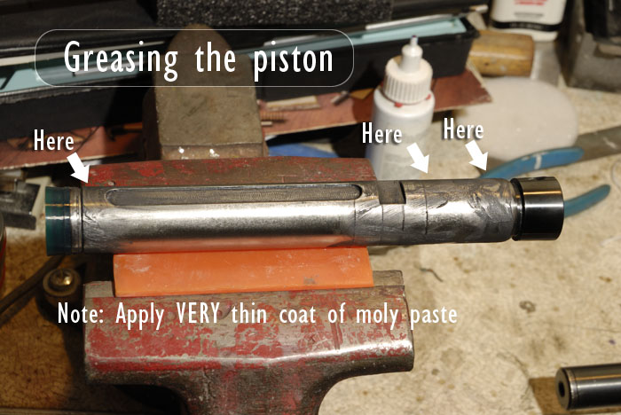
I'm open to hearing any tips on how others do this, or different variations. I used Metal to Metal moly paste on this part.
- (UPDATE)
I'm apparently incorrect about NOT putting (any) moly on the piston seal itself. I just heard from a reliable source, that (some) moly lube DOES get put around the sides of the seal (very light coat). Also a very fine film of moly should be burnished into the compression tube with a rag so there is just a fine film with no lumps or globs. You just don't want moly on the face of the seal.

- Lubing the inside of the gas strut:
This segment should have been shown before my last post. Sorry.
Thought I'd show a couple pics of how I prepped and lubed the inside of the gas strut. I first removed the inertia plug from the inside of the piston tube so I could get at all the old lube. The inertia plug fit snugly in the tube, so I did not replace the "O" rings on the inertia plug, I simply cleaned off the old lube, re-lubed it with Molykote 33 and re-installed it. I also used the shotgun cleaning rod with a soft head and small rag to remove all the old lube from the remainder of the piston tube.
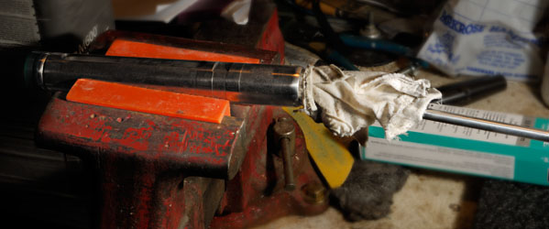
I removed the old "O" rings and back-up seal ring, then lubed the remainder of the tube with Molykote 33 before installing the new rings and back up seal. Then it was just a matter of sliding the two strut tubes back together. Picture below shows lubed up inner strut tube.
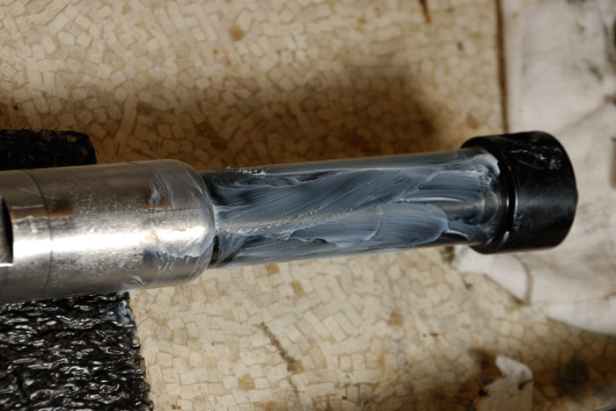
Note: The tubes should be pushed together before installing the strut assembly into the gun. As described in TIP, in the paragraph below.
TIP: When you slide the tubes together, you need to push in the Schrader valve at the same time, to release the trapped air, so that the tubes will slide ALL THE WAY together. I used a metal punch to hold in the Schrader pin as I slid the tubes together. You want the tubes completely together when you slide the piston assembly into the gun.

